Continental A&C-Series Aircraft Engines
Parts Interchangeability Catalogue

Note: This document is an electronic version of a historical document, not an official publication. It was generated from an electronically-scanned version of the a copy of the original. Errors may have been introduced during several steps in the process. No claim of accuracy is or can be made. It is highly recommended that users cross-reference information contained herein with official Continental publications
Table of Contents
SECTION 1 – CRANKCASE GROUP 1
CRANKCASE ASSEMBLIES: 1
BUSHING - ENGINE MOUNT – RUBBER: 1
GASKETS: 1
SECTION 2 - CRANKSHAFT ASSEMBLIES & RELATED PARTS 2
CRANKSHAFT ASSEMBLIES: 2
MAIN BEARING SETS: 2
CRANKSHAFT OIL-SEALS: 3
CRANKSHAFT GEARS: 3
PROPELLER HUB ASSEMBLIES: 3
SECTION 3: CONNECTING ROD ASSEMBLIES 4
ROD ASSEMBLIES: 4
SECTION 4: CAMSHAFTS, VALVE LIFTERS, & PUSHRODS 5
CAMSHAFTS: 5
LIFTER ASSEMBLIES: 6
PUSHROD ASSEMBLIES: 7
SECTION 5: PISTON ASSEMBLIES 8
PISTONS: 8
PIN AND PLUG ASSEMBLIES: 8
RING SETS: 9
SECTION 6: CYLINDER ASSEMBLIES 10
CYLINDERS: 10
VALVES: 10
INSERTS - VALVE: 10
GUIDES - VALVE: 11
SPRINGS - VALVE: 11
RETAINER - VALVE SPRINGS: 11
SEAT - VALVE SPRING: 11
LOCK - VALVE SPRING SEAT: 11
VALVE ROCKER ASSEMBLIES: (including shaft and cover) 12
GASKETS: 12
SECTION 7: OIL SUMP ASSEMBLIES 13
SUMP ASSEMBLIES: 13
GASKETS: 13
SECTION 8: CRANKCASE COVER ASSEMBLIES 14
COVER ASSEMBLIES: 14
HOUSING - TACHOMETER DRIVE: 14
OIL SEAL - TACHOMETER DRIVE: 14
OIL SCREEN ASSEMBLIES: 14
OIL SUCTION SCREENS OR TUBES: 15
OIL PUMP GEARS AND COVER: 15
GASKETS: 15
SECTION 9: OIL COOLER EQUIPMENT 16
OIL COOLERS: 16
SECTION 10: CARBURETOR INDUCTION SYSTEMS 17
CARBURETORS: 17
INTAKE & FILTER ASSEMBLIES - CARBURETOR AIR: 17
INTAKE MANIFOLD ASSEMBLIES: 18
INTAKE ELBOWS: 18
PIPE, HOSE & CLAMPS - INTAKE MANIFOLD: 19
PRIMERS-JETS: 19
GASKETS: 19
SECTION 11: IGNITION SYSTEMS 20
MAGNETO AND GEAR ASSEMBLIES: 20
GASKETS: 20
SECTION 12: STARTER, GENERATOR & VOLTAGE REGULATOR 21
DELCO-REMY AIRCRAFT EQUIPMENT FOR C75, C85, C90, Cl25, Cl45: 21
RELATED PARTS - STARTER: 21
RELATED PARTS - GENERATOR: 21
SECTION 13: FUEL PUMP EQUIPMENT 22
FUEL PUMPS: 22
COVER - FUEL PUMP PAD: 22
GASKET - FUEL PUMP: 22
SECTION 14: GASKET SETS 23
OVERHAUL GASKET SETS: 23
SECTION 15: MISCELLANEOUS INFORMATION 24
WARRANTY POLICY 24
IDENTIFICATION OF STUD SIZES 25
ENGINE MODEL DESIGNATIONS 26

SECTION 1 – CRANKCASE GROUP

CRANKCASE ASSEMBLIES:
A series:
6759-A1
C series:
50325-A1 (C85-8, C90-8)
6795-A1 (C75 C85-12, C90-12)
530135-A1 (C75, C85-12, with old type crankshafts #A5334, A50446, A35908, A36148, having tapered front surface on front thrust bearing flange)
530638-A1 (C90-14 - late Cessna l40)
530837-A1 (C125, C145 - heavy case)
Beginning with C125-2 engine #8205-9-2 and Cl45-2 engine #4384-D-9-2, a redesign in crankcase became effective. The original crankcase design (#6643-A1) was replaced with an entirely new design (#530837-A1) incorporating heavier deck sections and complete through-bolts instead of the original through studs threaded into the bearing blocks of the 2-4-6 crankcase half.
Listed below are approved combinations for C125 and C145 engines:
 | These Go Together | These Go Together | These Go Together | These Go Together
Crankcase | 6643-A1 | 6643-A1 | 530837-A1 | 530837-A1
Accessory case | 6715-A2 | 530007-A2 | 6715-A2 | 530007-A2
Oil sump (C145) | 530488 | 530958 | 530488 | 530958
Oil sump (Cl25) | 6638-A1 | 530887-A1 | 6638-A1 | 530887-A1
Accessory case gasket | 530909 | 530011 | 530909 | 530011
NOTE: C125 engines #8219-0-2 and lower, and C145-2 engines #5031-D-0-2 and lower should have installed on them the #531001 and #531003 flanged nuts on all cylinder hold-down studs and crankcase through-bolts in order to minimize the possibility of crankcase cracking. These nuts should not be installed without using a torque wrench.

BUSHING - ENGINE MOUNT – RUBBER:
22387 (A series, C75, C85, C90)
530740 (C90-14)
23411 (C125, C145)

GASKETS:
21064 (fuel pump - with 5390-A1 c'ase assy. - A series)
530642 (fuel pump cover pad - C series)
21170 (pushrod housing flange - A series) (same as 530928)
530928 (pushrod housing flange - C series) (same as 21170)

SECTION 2 - CRANKSHAFT ASSEMBLIES & RELATED PARTS

CRANKSHAFT ASSEMBLIES:
A series, C75, C85:
530196-A1 - taper - 3-5/8" stroke These shafts are interchangeable on all 4-cylinder engines except the C-90
530199-A1 - flange - 3-5/8" stroke These shafts are interchangeable on all 4-cylinder engines except the C-90
C90, C125, C145:
530182-A1 - 3-7/8" stroke (C90)
A50303-A1 (C125)
530860 (crankshaft & damper assy, - C145 – replaces #530243 undampened)
(Note: #530860 crankshaft & damper assy, is standard equipment in C145 engines #4435-D-9-2 and all higher numbers)
Nitrided crankshafts are standard equipment on engines bearing serial numbers listed below. (Note: All 6-cylinder engine crankshafts have always been nitrided):
A65: 61102-8-2 and all higher numbers
C75-12: 5257-8-12 and all higher numbers
C85-8, C85-12: 30435-8-8 and all higher numbers
C90-8F, C90-12F: 40000-8-12 and all higher numbers
C125-2: 1013-6-2 and all higher numbers
Cl45-2: 3001-8-2 and all higher numbers
All Continental reground crankshafts

MAIN BEARING SETS:
NOTE: Main bearings are interchangeable on all 4-cylinder engines with the exception of the front thrust bearing, which is different on the "A" and "C" series.
A series:
40237-A1..... Includes following:
2 36128 bearings - center & rear, 1-3
2 36129 bearings - center & rear, 2-4
2 40237 bearings - front & thrust
C series:
530058-A1 (C75, C85, C90 - replaces 40338-A2)... Includes following:
2 530058 insert - front main bearing (was 40338)
2 36128 insert - center & rear main bearing, 1-3
2 36129 insert - center & rear main bearing, 2-k
2 36075 thrust washer - upper front & lower rear half
2 A36074 thrust washer - lower front & upper rear half
(Note: #36075 and #A36074 thrust washers replace #35552 thrust washers)
36170-Al (C125, C145 )... Includes following:
6 36171 insert - intermediate & rear main bearing
2 36170 .insert - front main bearing
2 35562 thrust washer - upper front & lower rear
2 35563 thrust -washer - lower front & upper rear
530516-A1 (C145-2H) ..... Includes following:
6 36171 insert - intermediate & rear main bearing
2 530516 insert - front main bearing (tri-metal bronze)
2 35562 thrust washer - upper front & lower rear
2 35563 thrust washer - lower front & upper rear
NOTE: #36170-Al and #5305l6-Al bearing sets are interchangeable either way, except that when #36170-Al set is used in the C145-2H engine, you can not use the hydraulic propeller control.

CRANKSHAFT OIL-SEALS:
NOTE: All 4-cylinder engines use the same crankshaft oil seals, depending on which type of crankshaft (flange or taper) is installed.
A series, C75, C85. C90:
24321 (for tapered shaft)
530019 (for flange shaft - split type)
C125, C145:
530917 (split type)

CRANKSHAFT GEARS:
21083 (A series)
530641 (C85-8, C90-8 - replaces 21083 for C85-8)
35016 (C75-12, C85-12, C90-12, C125-2, C145-2, C145-2H)

PROPELLER HUB ASSEMBLIES:
NOTE: All 4-cylinder engines use the same hub assembly, depending on which type of crankshaft (flange or taper) is installed. :
A series, C75, C85, C90:
A3746 (for tapered shaft)
3991 (for flange shaft)
C125, C145:
35954

SECTION 3: CONNECTING ROD ASSEMBLIES

ROD ASSEMBLIES:
NOTE: Assembly number followed by -A2 includes rod and bushing assy. only. Assembly number followed by -Al includes rod and bushing assy., plus rod bearings,
A series:
A35158-A1 (A50)
A35159-A1 (A75, A80 - drilled cap - use only with A25127 pin assy. - heavy wall)
A35160-A1 (A65)
Above assemblies include rod, cap, and following:
1 21003 bushing - piston pin (A50, A75, A80).,..OR
1 22255 or 25369 bushing - piston pin (A65)
2 21004 bolt - connecting rod
2 2458 nut - connecting rod
2 2506 cotter pin - connecting rod bolt

2 (halves) 35897 bearing - upper or lower
C series:
A35160-A1 (C75, C85, C125 )....Includes following:
1 5561 rod & cap - connecting (not sold)
1 22255 or 25369 bushing - piston pin
2 530213 bolt - connecting rod – spec. 3/8-24
2 24804 nut - slotted hex - 3/8-24 x 21/64 high
2 2501 cotter pin – l/16 x 1/2
2 (halves) 35897 bearing - upper or lower (replaces 35947 for C125)
530184-A1 (C90, C145)..... Includes following:
1 530186 rod & cap - connecting (not sold)
1 22255 or 25369 or 530192 bushing - piston pin
2 530213 bolt - connecting rod
2 24804 nut - connecting rod
2 2501 cotter pin - connecting rod bolt

2 (halves) 35897 bearing - upper or lower (replaces 35947 for C145)

NOTICE THAT CONNECTING ROD BEARINGS ARE THE SAME FOR ALL "A" AND "C" SERIES

SECTION 4: CAMSHAFTS, VALVE LIFTERS, & PUSHRODS

CAMSHAFTS:
A series:
4546
C series:
40584 - cast iron (C75, C85 - side fuel pump or none)
24652 - cast iron (C75, C85 - fuel injector drive)
24435 - cast iron (C85-12, C85-12F - dual fuel pump drive)
530788 - steel (C90 - carburetor only - side fuel pump or none - replaced by 531076)
530977 - steel (C90 - carburetor or injector – replaced by 531146)
531076 - steel (C90 - carburetor only - replaces 530788)
531146 - steel (C90 - carburetor or injector – replaces 530977)
5974 - cast iron (C125)
530803 - steel (Cl45)
In the C90 engines, the original cast iron camshafts were replaced by steel camshafts as follows:
In engines #41602-12-8 and all higher numbers, except #41607-8-8, the #530185 camshaft was replaced by the #530788: and the #530427 camshaft was replaced by the #530977.
Beginning with C90-8F, 8FJ, and 12FJ engine #42205-9-12, and all C90-12F, the cam contour was changed to reduce valve overlap to 24°. The new camshaft number is 531076 for carburetor engines and 531146 for fuel injection engines. (#531146 may also be used in carburetor engines, but #531076 MAY NOT BE USED in fuel injection engines).
In C145-2 engines #4143-2-8, #4144-2-8, #4148-2-8 and all higher numbers, the #530397 cast iron camshaft was replaced by the #530803 steel camshaft.
IDENTIFICATION OF CAMSHAFTS: Forged steel camshafts are copper plated on the unfinished areas. If the Parko-Lubrite (black) coating covers the area, it may be scraped lightly with a blunt instrument to expose the copper plate. Do not remove the lubrite coating from cam lobes and journals.
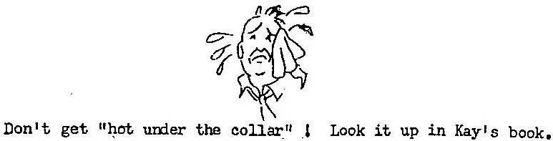

LIFTER ASSEMBLIES:
A series:
**A21325 (used with A21355 pushrod only).... Includes following:
8 21389 body - hydraulic valve lifter
8 25042 socket - pushrod
8, 21390 unit - valve lifter hydraulic
*A21599 (used with A21509 pushrod only).... Includes following:
8 21608 body- hydraulic valve lifter
8 25042 socket - pushrod
8 531694 unit - valve, lifter hydraulic (replaces 21609)
**Used on A50 engines through #129197
**Used on A65 engines through #404298
**Used on A75 engines through #630398

*Used on A50 engines after #129197
*Used on A65 engines after #404298
*Used on A75 engines after #630398
*Used on all A80 engines
C series:
A21599 (C75, C85, with cast iron camshaft).... Includes following:
8 21608 body - hydraulic valve lifter
8 25042 socket - pushrod
8 531694 unit - valve lifter hydraulic (replaces 21609)
530872 (C90 with steel camshafts #530788 & #530977)... Includes:
8 530873 body - hydraulic valve lifter
8 25042 socket - pushrod
8 531694 unit - valve lifter hydraulic (replaces 21609)
530850 (C90 with steel camshafts #531076 and #531l46 and C145 with #530803 camshaft).. Includes following:
8 or 12 530851 body - hydraulic valve lifter
8 or 12 25042 socket - pushrod
8 or 12 . 533399 unit - valve lifter hydraulic ( 3 to 6 second bleed-down)
A24205 (C125 with #5974 camshaft).... Includes following:
12 24205 body - hydraulic valve lifter
12 25042 socket - pushrod
12 531694 unit - valve lifter hydraulic (replaces 21609)
CAUTION: Similarity of new and old types of camshafts and valve lifters will require the exercise of caution and care in stocking and installing these parts. It is ESSENTIAL that only steel faced valve lifters be installed in combination with cast iron camshafts, and cast iron faced lifters in combination with forged steel camshafts.
If the large diameter steel lifters #530851) are to be installed in some older crankcases, you may have to burr the case a little so that you will have sufficient clearance for the base of the lifter.

IDENTIFICATION OF VALVE LIFTERS: Valve lifters may be identified by the thickness of the cam follower "foot" (the disc of the lifter body which makes contact with the cam lobe) at its perimeter. Steel faced followers are all 1/8" thick, while cast iron faced followers are all 11/64" thick. The 3/64" difference is easily noticeable on comparison.
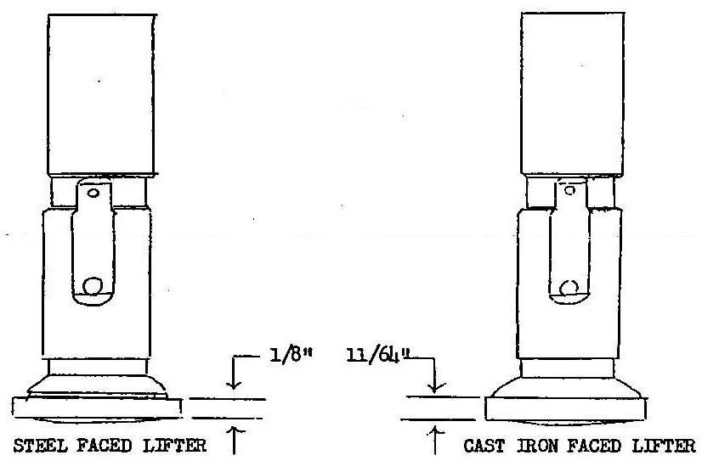

PUSHROD ASSEMBLIES:
A series:
**A21355 (4se with A21325 lifter assy. only)
*A2l509 (4se with A21599 lifter assy. only)
**Used on A50 engines through #129197
**Used on A65 engines through #404298
**Used on A75 engines through #630398

*Used on A50 engines after #129197
*Used on A65 engines after #404298
*Used on A75 engines after #630398
*Used on all A80 engines
C series:
A21509

SECTION 5: PISTON ASSEMBLIES

PISTONS:
A series:
4544 (A50 - 4 ring)
40312 (A65 - 3 ring - old type)
40731 (A65 - 3 ring - cam ground)
40577 (A75 - 3 ring)
4638 (A75 - 5 ring)
4701 (A80 - 5 ring)
C series:
40327 (C75, C85, C125 - 4 ring)
530348 (C90, C145 - 4 ring)

PIN AND PLUG ASSEMBLIES:
A series:
A25127 (A50, old type A65, A75, A80). ...Includes following:
1 25127 pin (0.859" diameter - heavy wall - replaces A21422)
2 25117 plug
25256-A1 (cam ground A65)....Includes following:
1 25256 pin (0.9215" diameter)
2 25117 plug
Note: Can also use #530856 assembly (with press fit plug) for cam ground A65.
C series:
530830. ... Includes following:
1 530829 pin (not sold)
2 530828 plug (not sold)
Engines having #530830 pin & plug assembly as standard equipment are:
C90: #4l35l-8-8 and higher
C145: #3776-8-2 and higher
As of November 4, 1948, all C145 and C90 engines in all aircraft manufacturers' stocks have been modernized, and ,regardless of engine serial number, any aircraft shipped subsequent to this date will not require the piston pin change. Also, any engines processed at Continental Motors and shipped after this date will have new type piston pins installed, regardless of serial number.
The press fit plug assembly #530830) can be used in all "C" series pistons, but MUST be used in the C90 and C145 engines. The C75 and C85 engines can use the separate pin and plug assembly (#25262 pin and #25117 plug) but the press fit plug assembly is better.

RING SETS:
A series:
Set No.
A22205 (A50, 4 ring A65 )... Includes following:
4 35551 ring - compression (taper face) (same as 530144)
4 35597 ring - compression (plain)
8 35595 ring - oil control
B22205 (5 ring A75, A80)...Includes following:
8 35551 ring - compression (taper face) (same as 530144)
4 35597 ring - compression (plain)
8 35595 ring - oil control
530144-A1 (A65 & A75, 3 ring) (same as 35670-Al)... Includes:
8 530144 ring - compression (taper face)
4 530145 ring - oil control (slotted)
Note: #35670-Al set includes 8 #3555l compression rings and 4 #3574l oil control rings.
C series:
Set No.
40691-A1 (C75, C85)..... Includes following:
4 36044 ring - top compression
8 40691 ring - 2nd & 3rd compression (same as 531491)
4 36058 ring - bottom slotted oil control
40691-A2 (C125)..... Includes following:
6 36044 ring - top compression
12 40691 ring - 2nd & 3rd compression (same as 531491)
6 36058 ring - bottom slotted oil control
530677-A1 (C90)..... Includes following:
4 36044 ring - top compression
8 40691 ring - 2nd & 3rd compression (same as 531491)
4 530677 ring - bottom slotted oil control (same as 531554)
530677-A2 (C145)..... Includes following:
6 36044 ring - top compression
12 40691 ring - 2nd & 3rd compression (same as 531491)
6 530677 ring - bottom slotted oil control (same as 531554)
Ring sets bearing the same part number, but ending in Al or A2, or B1 or B2 are the same. For example, ring set #530677 -Al is the same as #530677-Bl; ring Set #40691-A2 is the same as #40691-B2.

SECTION 6: CYLINDER ASSEMBLIES

CYLINDERS:
A series:
B3762
C series:
A50222
Engines with following serial numbers have shot-peened cylinders:
C85: 31212 and higher
C90: 42774 and higher
C145: 5592 and higher
All "C" series 4 and 6 cylinder remanufactured engines shipped from Continental Motors Corporation after January 1, 1951.
NOTE: Cylinder flanges which are not shot-peened will show a definite circular pattern left by the spot facing tool at the nut seat around the stud-hole. On shot-peened cylinders this nut seat is spot faced before shot-peening and this pattern is not evident. The shot-peening process leaves a speckled surface appearance and in profile would show a series of minute indentations in the metal.

VALVES:
A series:
21359 - intake valve
22211 - exhaust valve (A50, A65)
21479 - stellite exhaust valve (A75, A80, & can be used on A65)
C series:
3920 - intake valve
3921 - exhaust valve

INSERTS - VALVE:
A series:
2002 - spark plug insert (oversize inserts are stamped)
24805 - exhaust valve seat insert
24806 - intake valve seat insert
C series:
2002 - spark plug insert
3912 - intake valve seat insert
3923 - exhaust valve seat insert

GUIDES - VALVE:
A series:
21419 - intake valve guide
25276 - exhaust valve guide
(Note: Oversize guides are stamped)
C series:
24024 - intake valve guide
24047- exhaust valve guide

SPRINGS - VALVE:
A series:
21365 - inner
21366 - outer
C series:
24029 – inner (C75, C85)
24030 – outer "
24031 - inner (C90, C125, C145)
24029 – intermediate "
24030 - outer "
NOTE: The two-spring set-up for the C90 engines (#24031 inner:#24669 outer) has been replaced by the above three-spring combination. There are very few engines left with the two-spring set-up, and the three-spring set-up MUST BE USED with late type steel camshafts.

RETAINER - VALVE SPRINGS:
A series:
21025 - valve spring retainer
C series:
24026 - intake valve spring retainer
24044 - exhaust valve spring retainer

SEAT - VALVE SPRING:
A series:
21119
C series:
24027

LOCK - VALVE SPRING SEAT:
A & C series:
21361

VALVE ROCKER ASSEMBLIES: (including shaft and cover)
A & C series:
A24122 - valve rocker assembly.... Includes following:
1 35636 arm - valve rocker (not sold)
1 24122 bushing - valve rocker arm
2 21007 screw - type U drive - 1/8"
21153 - shaft - valve rocker
40762 - cover - valve rocker

GASKETS:
21477 - cylinder base packing (A & C series)
21493 - exhaust flange gasket (A & C series - replaces 25376)
530783 -valve rocker cover gasket (A & C series - same as 530162)

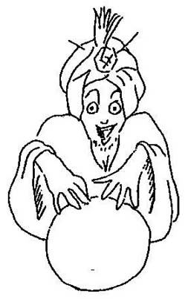

SECTION 7: OIL SUMP ASSEMBLIES

SUMP ASSEMBLIES:
All four-cylinder engines:
Briefly, there are actually only two oil sumps, or oil pans.
One has a maximum capacity of 4.8 quarts, and its capacity is rated according to how the oil stick is marked. The location, length, and angle of the neck determine which airplane it fits the best. However, most of the airplanes can interchange oil sumps without making the filler neck too inaccessible.
The other sump is used on Luscombes and Aeronca Champions or Chiefs. This is a 6-quart-plus sump and is shaped differently .than the 4.8 quart sump.
C125 and Cl45:
530887-A1 (C125) (Use with c'case cover #530007-A1)
530958 (C145) (Use with c'case cover #530007-A1)
Beginning with C125-2 engine #8205-9-2 and C145-2 engine #4384-D-9-2, a new type oil sump is used including five tapped holes for the sump-to-accessory case attaching cap screws, instead of three tapped holes for these attaching screws, Original part number for the C125 was #6638-Al; new part number is #530887-Al...... Original part number for the C145 was #530488; new part number is #530958.
The sump assemblies for the C125 and C145 are identical except for the addition of an induction baffle riveted at the top of the manifold riser on the C145 sump assembly.
NOTE: See also Section 1 for approved combinations of crankcase, accessory case, oil sump, and accessory case gasket for C125 and C145 engines.

GASKETS:
3577 - oil sump gasket (A series, C75, C85, C90)
530899 - oil sump gasket (C125, C145)
22404 - oil filler cap gasket (A & C series)

SECTION 8: CRANKCASE COVER ASSEMBLIES

COVER ASSEMBLIES:
A series:
A4587
C series:
A4587 (C85-8, 8F, 8FJ: C90-8F, 8FJ)
6726-A2 (C75-12, C85-12, C90-12)
6715-A2 (C125, C145 - OLD TYPE)
530007-A2 (C125, C145 - NEW TYPE - must use 530887-A1 sump)
Beginning with C125-2 engines #8205-9-2 and C145-2 engine #4384-D-9-2, the accessory case was modified to make provisions for five instead of three oil pan attachment cap screws. The original type accessory case with three holes for pan attaching cap screws is identified by- part number 6715-A2, and the new case with five holes is identified by part number 530007-A2.
NOTE: See also Page 1 (section 1) for approved combinations of crankcase, accessory case, oil sump, and accessory case gasket for C125 and C145 engines.

HOUSING - TACHOMETER DRIVE:
A series:
A21208
C series:
21208 (C85-8, C90-8)
35018 (C75, C85-12, C90-12)
35342 (C125, C145)

OIL SEAL - TACHOMETER DRIVE:
A series
530156 (same as 21163)
C series:
530156 (C85-8, C90-8, C125-2, C145-2, C145-2H - same as 21163)
21163 (C75-12, C85-12, C90-12 - same as 530156)

OIL SCREEN ASSEMBLIES:
A series:
A3568
C series:
A3568 (C75, C85, C90. Also C125 & C145 with #6715 cover)
530003 (C125 & C145 with #530007 cover)

OIL SUCTION SCREENS OR TUBES:
A series:
A22301 tube assy. (includes tube, nut, and screen)
C series:
A22301 tube assy. (C75, C85, C90)
530005 screen assy. (C125, C145 with #530007 cover)
A20878 screen assy. (C125, Gl45 with #6715 cover)

OIL PUMP GEARS AND COVER:
NOTE: There are only two oil pump gear and cover combinations for all 4-cylinder engines. One is for all -8 engines: the other for all -12.
A series, C75, C85, C90:
3562 gear & drive-shaft – oil pressure pump -8 engines
21343 gear & shaft - oil pressure pump (driven) - -8 engines
21160 cover - oil pressure pump -8 engines

22354 gear - oil pump driver -12 engines
22355 gear - oil pump driven -12 engines
23410 cover - oil pump -12 engines
C125, C145:
23403 gear - oil pump drive
35343 gear - oil pump driven & tach drive
23410 cover - oil pump

GASKETS:
35019 - tach drive housing & generator (C75, C85-12, C90-12)
36100 - tach drive housing & generator (C125, C145)

4577 - cover to c'case (A series, C85-8, C90-8)
5484 - cover to c'case (C75, C85-12, C90-12)
530909 - cover to c'case (C125 & C145 with #6715 cover - OLD TYPE)
530011 - cover to c'case (C125 & C145 with #530007 cover - NEW TYPE)
The original design accessory case and oil sump for C125 and C145 engines with provisions for sump-to-accessory case attachment with three cap screws requires #530909 gasket. The later design accessory case and oil sump with provisions for sump-to-accessory case attachment with five screws requires #530011 gasket,

SECTION 9: OIL COOLER EQUIPMENT

OIL COOLERS:
A series:
3883
C series:
3883 (C75, C85, C90)
EQ5334 (optional on C75-12. C85-12, C90-12)
EQ5392 (C125 - Globe Swift)
EQ5435 (C145 - Aeronca Sedan)

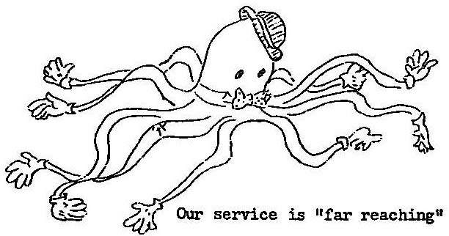

SECTION 10: CARBURETOR INDUCTION SYSTEMS

CARBURETORS:
NOTE: All 4-cylinder Stromberg carburetors are interchangeable, with the exception of the Venturis and jets (mixture control equipment has been optional, but, other than this, the carburetors are the same}.
4-cylinder venturi and jet numbers are as follows:
Venturi Jet
A series 1-1/4" #49
C75 1-5/16" #46
C85 1-3/8" #45
C90 1-3/8" #44
(There may be some slight variations to what we have stated above- but we nearly went nuts trying to figure it out, and we believe you will find that, in almost all cases, the above will hold true)

INTAKE & FILTER ASSEMBLIES - CARBURETOR AIR:
A Series:
EQ5370 (Stromberg),.... Includes following:
1 A40522 intake assembly
1 A50256 housing assembly
1 40599 filter - carburetor air
4 24306 stud - filter to housing
4 24308 cross pin
1 35923 gasket - filter to housing
1 A35917 support assembly - intake housing

A40793-A1 (Marvel-Schebler)..... Includes following:
1 A50793 intake assembly
1 A50495 housing assembly
1 40599 filter - carburetor air
4 24306 stud - filter to housing
4 24308 cross pin
1 35923 gasket - filter to housing
1 A35917 support assembly - intake housing
(Handwritten note on original: "Note – Aeronca Champ and Chief use their own assembly")
C series:
A40522 (C75, C85, C90)... Includes following attaching parts:
4 21393 stud - drilled lA-20 x l/4-28 x 7/8
1 21323 gasket - air intake housing to carburetor
4 2456 nut - hex castle - lA-28
*AR 2220 lockwire - brass - .040" diameter
1 A50256 housing assembly
1 40599 filter - carburetor air
1 35923 gasket - air filter to housing
4 24306 stud - filter camlock
4 24308 pin - camlock stud cross
1 A35917 support assembly - carburetor air intake
2 AN501A10-5 screw - fillister drilled head #10-32 x 5/l6
2 2471 washer - plain - 13/64 ID x 7/l6 QD x 1/32
**531143 (C125, C145 )...Includes following attaching parts:
**4 21393 stud - carburetor bottom flange
1 21323 gasket - carburetor to intake assembly
4 2456-nut - hex-castle - l/4-28
*AR 2220 lockwire - .040" diameter - brass
1 530852 housing assembly - carburetor air intake
1 40689 filter - carburetor air
1 36050 gasket - filter to intake housing
4 24308 pin - camlock stud cross
4 24306 stud - filter camlock
* As required.
** For C125-2 in Globe Swift, use A40793 intake assembly, 22719 adapter, and 23401 stud in place of above parts.

INTAKE MANIFOLD ASSEMBLIES:
A series:
4780-A1 (includes manifold and four #23401 studs)
C series:
35145-A1 (C75, C85, C90) (includes manifold & 4 #23401 studs)
6669 (C125, C145)

INTAKE ELBOWS:
A series:
3585 - intake elbow - cylinders 2 & 3
4602 - intake elbow - cylinders 1 & 4
C series:
40246 - intake elbow - cylinders 1 & 4 (C75, C85, C90)
40247 - intake elbow - cylinders 2 & 3 (C75, C85, C90)
40479 - intake elbow - cylinders 2 & 5 (C125, C145)
40480 - intake elbow - cylinders 1, 3, 4, 6 (C125, C145)

PIPE, HOSE & CLAMPS - INTAKE MANIFOLD:
A series:
4 21182 pipe - intake
8 22800 hose. -.1-3/4 OD - intake pipe to manifold & elbow
8 21185 hose - 1-1/2 OD - intake pipe to manifold & elbow
16 36151-B clamp - intake pipe hose
C series:
4 21182 pipe - intake (C75, C85, C90)
8 22800 hose - intake pipe to manifold & elbow (C75, C85, C90)
8 21185 hose - intake pipe to manifold & elbow (C75, C85, C90)
16 36151-B clamp - intake pipe hose (C75, C85, C90)
6 22800 hose - manifold to elbow (C125, C145)
12 36151-B clamp (C125, C145)

PRIMERS-JETS:
A series:
24758-A1 (assembly)
C series:
AN4022-1 (C75, C85, C90)

GASKETS:
21051 - carburetor to intake manifold (A & C series)
21323 - carburetor to housing (A & C series)
21327 - intake elbow (A series)
22250 - intake manifold (C series)
24759 - intake manifold to sump (C125, C145)
35923 - filter to intake housing (A series. C75, C85, C90)
36050 - filter to intake housing (C125, Cl45)

SECTION 11: IGNITION SYSTEMS

MAGNETO AND GEAR ASSEMBLIES:
A series:
5394 magneto - Scintilla SF4R-8 - unshielded
3513 gear - magneto drive
5395 magneto - Scintilla SF4R-8 - Shielded
3513 gear - magneto drive
A50398 magneto & gear assy. - Case - left side - unshielded
50350-A1 magneto & gear assy. - Case - right side - unshielded
(NOTE: Case magnetos can not be shielded)
530143 - Eisemann - left side - unshielded - includes following:
1 50406 AM-4 magneto - impulse coupling
1 36067 gear - magneto drive
24739-A1 - Eisemann - right side - unshielded - includes following:
1 24739 AM-4 magneto - no impulse
1 3513 gear - magneto drive
C series:
C85-8
24739-A1 magneto & gear assy. - Eisemann - unshielded - Includes
1 24739 AM-4 magneto - direct drive - clockwise
1 3513 gear - magneto drive
530143 magneto & gear assy. - Includes following:
1 50406 AM-4 magneto - impulse coupling - clockwise
1 36067 gear - magneto drive
Optional on C75 and C85-12:
50405 magneto - Eisemann IA-4 - impulse - counter- clockwise
36066 gear - magneto drive
C75, C85-12, C90-12:
50483 magneto - Scintilla S4LN-21 - impulse - counter- clockwise
36066 gear - magneto drive
C85-8, C90-8:
530209 magneto - Scintilla S4RN-21 - impulse - clockwise
36067 gear - magneto drive
NOTE: Magnetos are interchangeable on all 4-cylinder –8 engines, and interchangeable on all 4-cylinder -12 engines, BUT -8 MAGNETOS ARE NOT INTERCHANGEABLE WITH -12 MAGNETOS.
C125, C145:
A40829 magneto & gear assy. - Includes following:
50484 magneto - Scintilla S6LN-21
530603 gear - magneto drive (replaces #35964)

GASKETS:
535324 - magneto flange gasket (A & C series - replaces 500278 and 352057)

SECTION 12: STARTER, GENERATOR & VOLTAGE REGULATOR

DELCO-REMY AIRCRAFT EQUIPMENT FOR C75, C85, C90, Cl25, Cl45:
Listed below are the correct generator & regulator combinations:
Generator Regulator
1101876 (12 amps) 1118383
1101879 (25 amps) 1118384
1101890 (20 amps) 1118736
Starter motor - 1109656
Starting switch - 1909305

RELATED PARTS - STARTER:
4044l starter pad
35904 gasket - starter pad - OLD TYPE
352179 gasket - starter pad - NEW TYPE

RELATED PARTS - GENERATOR:
25120 disc - generator coupling (OLD TYPE - replaces 22348)
530998 disc - generator coupling (NEW TYPE - two separate halves)
23515 cover - generator pad
35019 gasket - tach drive housing & generator (C75, C85, C90)
36100 gasket - tach drive housing & generator (C125, C145)
352068 oil seal - generator (replaces 246l4)
531325 gear - generator drive (replaces 530408 for C75, C85, & C90, and replaces 531014 for C125 & C145)
531014-A1 generator drive kit (all C series)

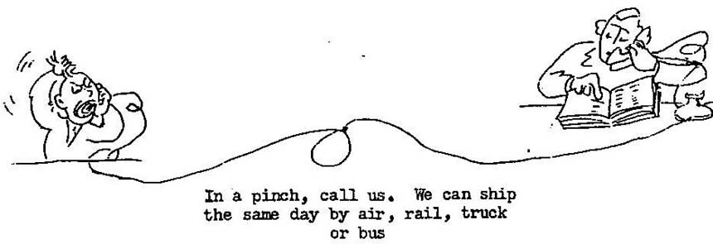

SECTION 13: FUEL PUMP EQUIPMENT

FUEL PUMPS:
A series:
4552
C series:
40452 lower fuel (C85-12)
40485 side mounted fuel (C125, C145, & optional on C75-12, C85-12, C90-12)
40695 side mounted fuel (optional on C75-12, C85-12, C90-12)

COVER - FUEL PUMP PAD:
A series:
21059
C series:
21059

GASKET - FUEL PUMP:
A series:
21064
C series:
530642
24915 (lower fuel pump - C85-12)

SECTION 14: GASKET SETS

OVERHAUL GASKET SETS:
A series:
A3972 top overhaul
B3973 major overhaul
C series:
24890-A1 top overhaul (C75, C85-12, C90-12)
24890-A2 major overhaul (C75, C85-12, C90-12)
24890-A3 top overhaul (C85-8, C90-8)
24890-A4 major overhaul) (C85-8, C90-8)
25103-A1 top overhaul (C125)
25103-A2 major overhaul (C125)
25103-A3 top overhaul (C145)
25103-A4 major overhaul (C145)
NOTE: None of the 4-cylinder gasket sets include a crankshaft oil seal.

SECTION 15: MISCELLANEOUS INFORMATION

WARRANTY POLICY
You might be interested to know something about Continental's warranty policy. As has always been the case, the final decision on all warranty matters is subject to the factory investigation of the defective parts or engines. A good distributor can help you a lot with your problems, but he can actually make no definite commitment until after factory inspection has been completed and final notification of the factory decision has been received.. You will, however, usually have better results if you go through your distributor on a warranty claim.
In general. Continental's warranty policy is as follows:
"Continental Motors Corporation warrants each new aircraft engine or aircraft engine part to be free from defects in material and workmanship when properly installed and used under normal conditions for one hundred fifty (150) days or in no case to exceed one hundred (100) hours of operation after the shipment of each engine or part from the plant. This warranty is limited to replacing or repairing at its shops any part or parts which have been returned to the Aircraft Engine Division with transportation charges prepaid, and which, in its opinion, are defective. This warranty is expressly in lieu of all other warranties or representations, expressed or implied, and all other liabilities on the part of Continental Motors Corporation.
"This warranty does not cover any labor charges for replacement of parts, adjustments, repairs or any other work done on Continental aircraft engines or parts.
"This warranty shall not apply to any engine or part which shall have been repaired or altered outside of our factory in any way so as, in our judgment, to affect its operation, or which has been subject to misuse, negligence or accident, or which shall have been operated at a 'speed exceeding the factory rated speed'.
"The Aircraft Engine Division of Continental Motors Corporation will warrant each new accessory furnished by it to be free from defects in material and workmanship for ninety (90) days or fifty (50) hours of operation after original installation in an aircraft. Since many of these accessories are procurable from other sources, this clause applies only to accessories purchased on engines or as spare parts from Continental Motors Corporation.
"The Aircraft Engine Division of Continental Motors Corporation reserves the right to change engine or parts specifications or prices without incurring any responsibility with regard to engines or parts previously sold or replaced."

IDENTIFICATION OF STUD SIZES
After about ten years of trying to memorize, by looks, the various oversize studs (.003, ,006, .009), we have finally put a picture of them up on our parts bin. We find that it helps considerably, and thought it might be of assistance to you. Here's how they look to us:

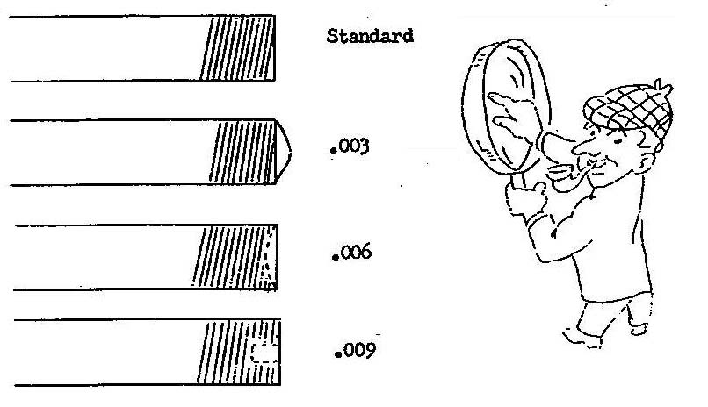

ENGINE MODEL DESIGNATIONS
It seems that lots of people (including us) become confused by engine model designations....or, in other words, they don't know for sure just what is indicated by the various "dash" numbers, etc. The following may clear up some of this confusion for you (or if you already knew what we are telling you and can add to our information, please do....we welcome any pertinent facts).
C85 and C90 engines are designated as C85-8, C85-12, C90-8F, C90-8FJ, etc. These various "dash" numbers and letters indicate the following:
-8: No provision for starter and generator
-12: Provision for starter and generator
-14: Provision for starter and generator, and "Lord" engine mounts (late Cessna l40 only)
F: Flange crankshaft
J: Fuel injector
Example: C90-12FJ indicates a 90 horsepower engine with starter and generator, flange crankshaft, and fuel injector.
C85 and C90 -8 and -12 engines have different accessory sections, different rotation of tachometer drive, and the magnetos are NOT interchangeable. You can not convert a -8 engine to a -12 engine in the field, or vice versa.
The C145-2 engine is the "common" 145 horsepower Continental engine. The C145-2H engine has provisions for a hydraulic propeller control. (See main tearing listings on Page 3 for difference in front main bearings).

