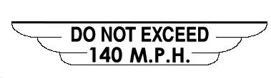
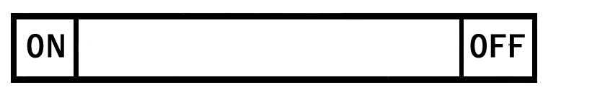
WHEN REMOVING CONTROL

REMOVE UNIVERSAL JOINT
REFILL MAIN TANK IN LEVEL FLIGHT AND ONLY
WHEN MAIN TANK IS LESS THAN HALF FULL.

