Reg.: Type: Reg. nr.: Reg. Date: Cancl.: State of the plane: (Red.: 08.03.2006)

OY-DUP Taylorcraft (Piper) J-2-40 Cub Assembled in Lundtofte 1938

C/nr.: 1319 ? 30.08.1939 Forskønnelsesforeningen for Slagelse og Omegn,

Slagelse (v/ J. Sejer Dybro, Slagelse ?)
LDB deponeret, maj 1940

Seized by the German Forces in December 1943

?.1946 Cancl.
Reg.: (NC17885), OY-DUP, GP+QG
LDB nr.: 124 (30.08.39)
Weight.: , Seats: 2
Remarks.: Build at Taylorcraft 1937, assembled by Cub Co., Lundtofte, DK, 1938.

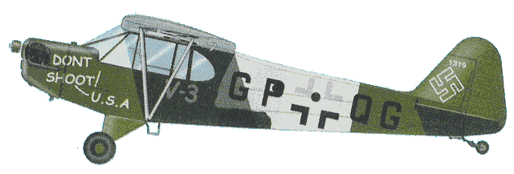
See:
http://maquettesavions.free.fr/PiperL4H.htm

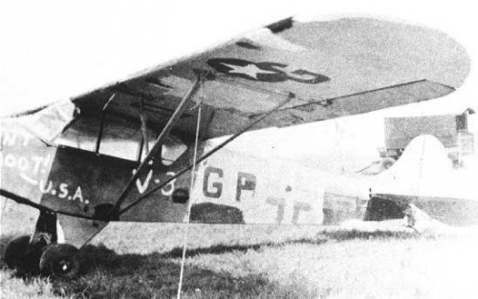
See:
http://pipercubforum.com/luftcubs

