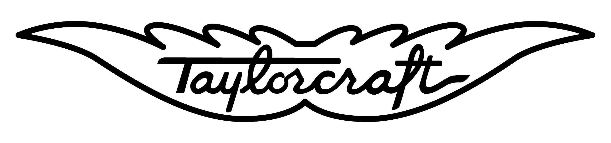

Taylorcraft Aviation, LLC Service Bulletin No. 2007-001
2124 Central Ave Date: April 2, 2007
Taylorcraft Considers Compliance Mandatory
Brownsville, TX 78521
Phone (956) 986-0700

Revision: 1R

SUBJECT:

Wing Lift Strut Assembly Corrosion Inspection/Replacement.

PURPOSE:

The actions specified by this Service Bulletin are intended to inspect for and detect any internal or external corrosion of the wing lift strut tube, and thereby prevent wing strut failure and in-flight separation of the wing from the airplane resulting in loss of control of the airplane. The corrosion is most likely to occur at the lower end of the left and right wing aft and forward lift struts (near the fuselage attachment). Since the lift struts are closed tubular structures, internal corrosion in most cases is not readily apparent until the corrosion advances through the tube wall. This corrosion, if allowed to progress, may lead to failure of the wing lift strut, and probable loss of wing structure integrity. This Service Bulletin provides an inspection procedure to detect evidence of wing lift strut tube internal and external corrosion.

FOR FURTHER INFORMATION CONTACT:

Engineering Department Parts Department
956-986-0700 ext: 17 956-986-0700 ext: 14 or 15
Engineering@Taylorcraft.com Parts@taylorcraft.com

EVENTS LEADING TO THE ISSUANCE OF THIS SERVICE BULLETIN:

Taylorcraft has received field reports of front and rear lift strut corrosion located within the bottom 12 inches of the struts. The corrosion can be severe enough that in some cases in-flight failure of the lift strut(s) may occur.

APPLICABILITY:

All Taylorcraft Aviation Airplane Models listed on Type Certificates A-696 and 1A9, to include the following airplane models, certificated in any category:
BC, BCS, BC-65, BCS-65, BC12-65, BCS12-65, BC12-D, BCS12-D, BC12-D1, BCS12-D1, BC12D-85, BCS12D-85, BC12D-4-85, BCS12D-4-85, 19, F19, F21, F21A, F21B, F22, F22A, F22B, F22C.

NOTE:
This Service Bulletin applies to each airplane identified in the preceding applicability provision, regardless of whether it has been modified, altered, or repaired in the area subject to the requirements of this Service Bulletin. For airplanes that have been modified, altered, or repaired so that the performance of the requirements of this Service Bulletin is affected, the owner/operator must request approval for an alternative method of compliance. The request should include an assessment of the effect of the modification, alteration, or repair on the unsafe condition addressed by this Service Bulletin; and, if the unsafe condition has not been eliminated, the request should include specific proposed actions to address it.

COMPLIANCE:

Perform Part 1 of the INSTRUCTIONS within the next thirty (30) calendar days. Perform Part 2 of the INSTRUCTIONS within the next three (3) calendar months; except, when corrosion is found during Part 1 of the INSTRUCTIONS, you must perform Part 2 of the INSTRUCTIONS prior to further flight. Re-inspect struts every twenty-four (24) months in accordance with Part 2 of the INSTRUCTIONS.

NOTE:
If the wing lift struts are new and have been installed within the last twenty –four (24) months, inspection is required no later than twenty-four (24) months after the time the new lift struts were installed.

TERMINATING ACTION:

Installation of new replacement sealed front lift strut, part number MA-A815, or new replacement sealed aft lift strut, part number MA-A854, is considered terminating action for the repetitive twenty-four (24) month inspections. Note that if not all lift struts are replaced with new sealed units, the struts that are not replaced shall be re-inspected at twenty-four (24) month intervals.

PERSONNEL REQUIREMENTS:

The inspection procedures in Appendix A or B must be accomplished by a Level II or Level III inspector certified in the applicable Eddy Current or Ultrasound Inspection method using the guidelines established by the American Society of Nondestructive Testing or NAS 410 (formerly MIL-STD-410), or an Inspector certified to specific FAA, or other acceptable government or industry standards, such as Air Transport Association (ATA) Specifications 105-Guidelines for Training and Qualifying Personnel in Nondestructive Testing Methods, or qualified FAA Repair Station, or a qualified Testing / Inspection Laboratory.

The person should be familiar with the test methods, know the potential types of discontinuities peculiar to the material, and be familiar with their effect on the structural integrity of the part.

INSTRUCTIONS:

Part 1
- Clean the lower eighteen (18) inches of the right and left wing forward and aft lift struts with a suitable cleaner to remove all dirt and grease (strut removal is not required).
- Visually inspect the right and left wing forward and aft lift struts for corrosion along the entire bottom twelve (12) inches of each strut. If, at any point, there is corrosion penetrating the entire thickness of the lift strut material, the strut should be replaced before the next flight. Clean the drain hole using safety wire or an equivalent thin gauge probe and observe any indications of internal rust.
- If any signs of corrosion, blistered paint, pitting, etc. of the lift strut material is observed, or, if during the removal and installation of the lift struts for other maintenance loose rust is heard or discovered inside the lift struts, perform Part 2 of these instructions prior to further flight.

Part 2
- Support and block both wings in position using suitable shoring.
- Remove lower and upper wing strut fairings.
- Remove the right and left wing aft struts from the airplane and annotate each strut for reinstallation on the same side it was removed.
- Turn each lift strut upside down and tap gently to remove any water, debris, or corrosion particles Clean the lower eighteen (18) inches of each lift strut with a suitable cleaner to remove all dirt and grease.
- Perform the eddy current inspection of the lower twelve (12) inches of the strut in accordance with the inspection procedure in Appendix A (preferred method) or ultrasound inspection in accordance with the procedure in Appendix B (alternate procedure).
- Verify suspected corrosion areas using the secondary inspection method in the appendix.
- If no external corrosion is visible and inspection results using Appendix A or B procedure are acceptable per ACCEPTANCE/REJECTION CRITERIA below, apply corrosion inhibitor to the inside of each lift strut in accordance with CORROSION INHIBITOR PROCEDURE below.
- Replace any strut having severe internal or external corrosion or that fails inspection using the ACCEPTANCE/REJECTION CRITTERIA below. Install new sealed wing lift struts, part numbers MA-A815 (front) and MA-A854 (rear).
- Reinstall reusable lift struts on same side removed per LIFT STRUT WING LEVELING PROCEDURE.
- Remove the left and right wing forward lift struts and annotate each strut for reinstallation on the same side it was removed.
- Repeat steps 4 through 9 above for the forward struts.
- After inspection it may be necessary to repair/touch up external painted surfaces of the strut surface to prevent future corrosion.
- Acceptable struts will require a unique identifier be applied to them for future record keeping and tracking. Rejected struts require tagging or permanent mutilation for future inspection or scrapping.
- Generate a report for inclusion in the aircraft history file to allow a log-book entry by the proper authority, in compliance with applicable regulations.

SUPPLEMENTARY INFORMATION:

- NDT inspection of the lift struts requires removing them from the airplane and testing them on a flat, level surface. In the process of removing the lift struts, please mark each one, and upon passing inspection reinstall it in the same position that it was removed from (i.e. the lift strut removed from the left rear position must be reinstalled on the left rear position, and not on the right rear position).
- Replacement lift struts are available from the factory and terminate the recurring inspection requirement. When ordering, please use the following part numbers:

MA-A815 Front Lift Strut
MA-A854 Rear Lift Strut

ACCEPTANCE/REJECTION CRITERIA:

- The following criteria shall be used for rejection and require replacement of the strut prior to further flight:
  - Any strut with corrosion through the thickness of the part
  - Any strut with cracks
  - Any strut exhibiting multiple pitting sites over a concentrated area
  - Any strut with corrosion that results in a remaining wall thickness of 0.020” or less over more than one (1) square inch of the total surface area
  - Any strut with corrosion evident over 30% or more of the required inspected surface area that results in a remaining wall thickness less than shown in the table below:

Strut  thickness (inch) | Minimum allowed  thickness (inch)
0.035 +/- 0.004 | 0.029
0.042 +/- 0.004 | 0.035
0.049 +/- 0.004 | 0.041

- If at any time during testing an area is encountered where a valid thickness measurement cannot be obtained due to a loss of signal strength or quality, the area shall be considered suspect. The suspect area(s) shall be tested using both the Appendix A Eddy Current and Appendix B Ultrasound methods to help determine the extent of the corrosion. Any strut that cannot be successfully tested to determine the extent or absence of possible corrosion, for whatever reason(s), shall be rejected and replaced prior to further flight.

CORROSION INHIBITOR PROCEDURE:

Before installing reusable struts, treat each strut for internal corrosion protection per the following procedure:
- Inject one quart of warm raw Linseed Oil, Paralketone or CRC3 (LPS Heavy Duty Rust Inhibitor Type 3) into the strut.
- Plug open holes in the strut and slosh oil until interior of strut is thoroughly coated.
- Drain oil from strut through an open hole.
- Reinstall strut on aircraft and check rigging per LIFT STRUT WING LEVELING PROCEDURE below.

LIFT STRUT WING LEVELING PROCEDURE:

Hold or block the wing in its approximate position while the wing struts are installed with the bolts provided. The proper amount of incidence is built into the fuselage fittings and the dihedral is fixed by the length of the front struts. The rear struts are adjusted at the factory and must be assemble as tagged. After the plane is out in service, it may change balance slightly, by developing wing heaviness. To correct this, remove the bolt at the upper end of the rear wing strut of the opposite of that which is heavy and unscrew the plug ½ turn or more until the balance is corrected. After an airplane has received a major overhaul, it may be advisable to check the complete rigging of the airplane. To accomplish this, level the plane laterally by attaching a cord from wing tip to wing tip over the front spar. Place a line level on the center of the string and level the plane by blocking up the low wheel by a jack or other means. Level the plane longitudinally by placing a level on the stabilizer close to and parallel to the fuselage. Use a 30” level to check the incidence at the tip of the wing, (readings to be taken on the first full rib from the tip). By placing the edge of the level at the forward part of the rear spar along the rib mentioned with the level in horizontal position, there will be a gap between the front edge of the level and the wing of 1 – 5/16”. The plug at the top of the rear strut is used for adjustment.

(See Figure on Next Page)
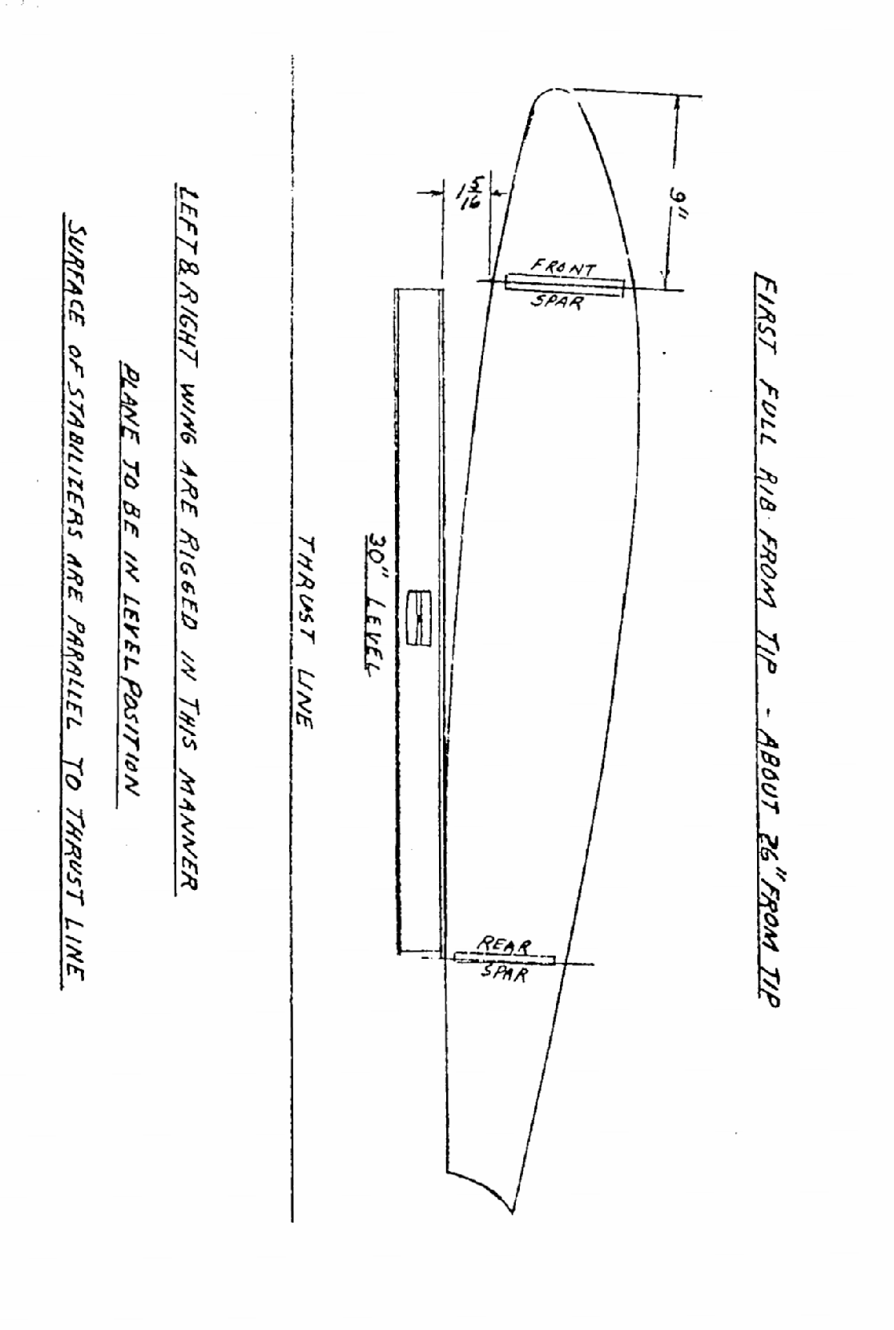

APPENDIX A

PROCEDURES AND REQUIREMENTS FOR EDDY CURRENT INSPECTION OF TAYLORCRAFT LIFT STRUTS

APPROVED PROCEDURES:

Title 14CFR, part 43 requires that all maintenance be performed using methods, techniques, and practices prescribed in the current manufacture’s maintenance manual or instructions for continued airworthiness prepare by its manufacturer, or other methods, techniques, and practices acceptable to the administrator. If the maintenance instructions include material, parts, tools, equipment, or test apparatus necessary to comply with industry practices then those items are required to be available and used as per part 43.

EDDY CURRENT:

Advantages Disadvantages
Portable Surface must be accessible to probe
Detects surface and subsurface discontinuities Rough surface interfere with test
Moderate speed Electrically conductive surfaces
Immediate results Skill and training required
Sensitive to small discontinuities Time consuming for large surface
Can detect many variables

CORROSION INSPECTIONS:

Eddy Current inspection is used to detect the loss of metal as a result of corrosion. An estimation of material loss due to corrosion can be made by comparison with thickness standards. Remove all surface corrosion before performing the Eddy Current corrosion inspection. Corrosion that has not broken away from the parent metal and is still dense enough to give erroneous indications while using Ultrasonic Inspection, will give a response similar to cracks. The composition of corrosion is such that is actually thousands of cracks in the parent metal and very close together.

EQUIPMENT REQUIREMENTS:

- A portable Eddy Current Test Set, Analog or Impedance Plane, which meets the liftoff and sensitivity requirements and capable of operation from 100Hz to 500Khz. The range of material measurement will be from 0.020” to 0.060”.

- A small, shielded surface probe, with a coil diameter between 0.15 and 0.25 inches, and capable of operation at the lower frequencies required for adequate depth penetration, to detect backside defects.

- A reference standard / test block with backside defects and various thicknesses is recommended, of the same relative material (mild or low alloy steel), to allow the operator to establish the response by that particular test set. Three different thicknesses of strut material were used in production. (0.035”, 0.042”, and 0.049”). It is recommended to make a test standard from 0.049” material which will cover all strut thicknesses. The various depths of thickness needed to calibrate on the standard may be manufactured by milling various steps in the test sample to replicate the different thicknesses expected to be encountered (0.049”, 0.042”, 0.035”, 0.029, 0.020).

An additional standard can be fashioned in a similar manner but by milling, to various depths, ¼ to 3/8 inch diameter holes in the test sample. This approach may better replicate the response expected to be detected for pitting on the struts; additionally, the shoulders of the milled holes will allow for interpreting the response when corrosion is adjacent to welds or intersections with other metal.

- Periodic calibration and maintenance is necessary to assure proper operation of the equipment. The frequency and extent of such checks may be determined by the user taking account of the use of the instrument, but should not be less frequent than the recommendations contained in the instrument manual. The user should implement a program of periodic calibration, cleaning, and maintenance to assure proper performance of the equipment.

FACTORS TO BE CONSIDERED BY THE OPERATOR:

Proper set-up and use of this equipment and performance of electromagnetic tests, however, requires familiarity with factors that are beyond the scope of operation manuals. These factors include considerations such as the following:

- Selection of appropriate cables, probes, fixtures, mechanical handling equipment and other accessories.

- Section of proper test frequency, test mode and other test parameters.

- Preparation of the test surfaces.

- Characteristics of the test material, for example: conductivity, hardness, permeability, geometry, magnetic properties, heat treatment, ect..

- Environment factors such as temperature, humidity, dust and electrical interference.

- Any individual factors that will depend on the particular test object or test being performed.

Suspected defects in critical areas should be verified using the alternate Ultrasonic Inspection procedure in Appendix B of this Service Bulletin.

INSTRUMENT SET-UP:

- Set-up of the instrument will be as specified in the manufactures operator manual. As there is a tremendous variety of instruments available, (it is beyond the scope of this guide to spell out detailed setups), it is mandatory that the operator have available the manual for that particular unit.

- Calibration of the instrument is dependent upon the response to known defects and thicknesses. Known defects / thicknesses will allow sensitivity adjustment which will enable proper interpretations and increase confidence levels. Additionally probe selection and verification is depended upon utilization of know defect artifacts also.

- If unit is battery powered care should be taken to keep it properly charged.

SURFACE PREPARATION OF STRUTS:

Eddy Current inspections can usually be performed without removing surface coating such as primer, paint, and anodic films. Wash and inspect the test area, if surface roughness or corrosion is present, the surface should be sanded and polished to provide a smooth surface for the probe to move across.

*** TIP***
Waxing helps to allow easy movement.
A very thin piece of Teflon tape applied to the probe tip will also allow smooth movement across the test piece surface (apply the tape before setting liftoff), and also will reduce wear of the probe tip.

INSPECTION PROCEDURE:

- After preparing the surface as described above – using a ruler or other flexible straight edge – draw parallel lines spaced about 1/4 inch apart on both faces of the lower 12 inches of the strut. Use a felt tip pen or a silver sheet metal marking pencil (lead should not be used on alloy steel), depending on the color of the strut paint. We recommend the parallel lines to allow the operator to move the probe without wandering and ascertain that full coverage of the inspection area has been accomplished. The areas can be check marked as each is inspected and reduced possible confusion. Suspect areas may be marked with a red or other contrasting felt tip pen for additional investigation.

- Move the probe lightly along the drawn lines across the work piece surface, maintaining the probe approximately perpendicular to the sample surface.

- a.) A crack will be indicated by a sharp response on the meter or display.

b.) Metal thinning, (from corrosion), will be indicated by movement towards the liftoff/balance point. Metal thickness can be determined by comparison to the test sample(s) previously fabricated as above.

- Inspection around the bottom plates, reinforcement areas, or flange plates will require careful interpretation of indications (this is where experience is important ).

- There are for inspection items of interest the operator is concerned with:
- Thickness of parent metal without corrosion
- Thickness of parent metal after corrosion effects
- Cracks on the parent metal
- Corrosion which show up as cracks and which will show by the instrument response how thick the corrosion layer is and how deep it has penetrated in the parent metal

- Another concern that should be taken into account is that welds cracks can begin with corrosion as it generates high stress points that will propagate though the weld zone.

- Any strut that has areas of corrosion and or minimum parent metal thickness limits as defined in the Service Bulletin shall be rejected.

APPENDIX B

PROCEDURES AND REQUIREMENTS FOR ULTRASONIC INSPECTION
OF LIFT STRUTS

EQUIPMENT REQUIREMENTS:

- A portable ultrasonic thickness gauge or flaw detector with echo-to-echo digital thickness readout capable of reading to 0.001-inch and an A-trace waveform display will be needed to accomplish this inspection.

- An ultrasonic probe with the following specifications will be needed to accomplish this inspection: 10 MHz (or higher), 0.283-inch (or smaller) diameter dual element or delay line transducer designed for thickness gauging. The transducer and ultrasonic system shall be capable of accurately measuring the thickness of AISI 4130 steel down to 0.020-inch. An accuracy of +/- 0.002-inch throughout a 0.020-inch to 0.060-inch thickness range while calibrating shall be the criteria for acceptance.

- Either a precision machined step wedge made of 4130 steel (or similar steel with equivalent sound velocity) or at least three shim samples of same material will be needed to accomplish this inspection. One thickness of the step wedge or shim shall be less than or equal to 0.020-inch, one shall be greater than or equal to 0.060-inch, and at least one other step or shim shall be between these two values.

- Glycerin, light oil, or similar non-water based ultrasonic couplants are recommended in the setup and inspection procedures. Water-based couplants, containing appropriate corrosion inhibitors, may be utilized, provided they are removed from both the reference standards and the test item after the inspection procedure is completed and adequate corrosion prevention steps are then taken to protect these items.

***NOTE***
If surface roughness due to paint loss or corrosion is present, the surface should be sanded or polished smooth before testing to assure a consistent and smooth surface for making contact with the transducer. Care shall be taken to remove a minimal amount of structural material. Paint repairs may be necessary after the inspection to prevent further corrosion damage from occurring. Removal of surface irregularities will enhance the accuracy of the inspection technique.

INSTRUMENT SETUP:

- Set up the ultrasonic equipment for thickness measurements as specified in the instrument's user's manual. Because of the variety of equipment available to perform ultrasonic thickness measurements, some modification to this general setup procedure may be necessary. However, the tolerance requirement of step 13 and the record keeping requirement of step 14 must be satisfied.

- If battery power will be employed, check to see that the battery has been properly charged. The testing will take approximately two hours. Screen brightness and contrast should be set to match environmental conditions.

- Verify that the instrument is set for the type of transducer being used, i.e. single or dual element, and that the frequency setting is compatible with the transducer.

- If a removable delay line is used, remove it and place a drop of couplant between the transducer face and the delay line to assure good transmission of ultrasonic energy. Reassemble the delay line transducer and continue.

- Program a velocity of 0.231-inch/microsecond into the ultrasonic unit unless an alternative instrument calibration procedure is used to set the sound velocity.

- Obtain a step wedge or steel shims per item 3 of the Equipment Requirements. Place the probe on the thickest sample using couplant. Rotate the transducer slightly back and forth to "ring" the transducer to the sample. Adjust the delay and range settings to arrive at an A- trace signal display with the first back wall echo from the steel near the left side of the screen and the second back wall echo near the right of the screen. Note that when a single element transducer is used, the initial pulse and the delay line/steel interface will be off of the screen to the left. Adjust the gain to place the amplitude of the first back wall signal at approximately 80% screen height on the A-trace.

- "Ring" the transducer on the thinnest step or shim using couplant. Select positive half-wave rectified, negative half-wave rectified or filtered signal display to obtain the cleanest signal. Adjust the pulse voltage, pulse width, and damping to obtain the best signal resolution. These settings can vary from one transducer to another and are also user dependent.

- Enable the thickness gate, and adjust the gate so that it starts at the first back wall echo and ends at the second back wall echo. (Measuring between the first and second back wall echoes will produce a measurement of the steel thickness that is not affected by the paint layer on the strut). If instability of the gate trigger occurs, adjust the gain, gate level, and/or damping to stabilize the thickness reading.

- Check the digital display reading and if it does not agree with the known thickness of the thinnest thickness, follow your instrument's calibration recommendations to produce the correct thickness reading. When a single element transducer is used this will usually involve adjusting the fine delay setting.

- Place the transducer on the thickest step of shim using couplant. Adjust the thickness gate width so that the gate is triggered by the second back wall reflection of the thick section. If the digital display does not agree with the thickest thickness, follow your instruments calibration recommendations to produce the correct thickness reading. A slight adjustment in the velocity may be necessary to get both the thinnest and the thickest reading correct. Document the changed velocity value.

- Place couplant on an area of the lift strut that is thought to be free of corrosion and "ring" the transducer to surface. Minor adjustments to the signal and gate settings may be required to account for coupling improvements resulting from the paint layer. The thickness gate level should be set just high enough so as not to be triggered by irrelevant signal noise. An area on the upper surface of the lift strut several inches above the inspection area would be a good location to complete this step and should produce a thickness reading between 0.031-inch and 0.053-inch.

***NOTE***
Lift struts were manufactured from different thickness tubing, based on the availability of the streamlined tubing at the time of manufacturing. As such, the thickness determined in this procedure should be achieved as carefully and as precisely as possible, as it will be used as a reference for determining the minimum acceptable thickness of the lift strut material.

- Repeat steps 8, 9, 10, and 11 until both thick and thin shim measurements are within tolerance and the lift strut measurement is reasonable and steady.

- Verify that the thickness value shown in the digital display is within +/- 0.002- inch of the correct value for each of the three or more steps of the setup wedge or shims. Make no further adjustments to the instrument settings.

- Record the ultrasonic versus actual thickness of all wedge steps or steel shims available as a record of setup.

INSPECTION PROCEDURE:

- Clean the lower 12 inches of the wing lift struts using a cleaner that will remove all dirt and grease. Dirt and grease will adversely affect the accuracy of the inspection technique. Light sanding or polishing may also be required to reduce surface roughness as noted in the Equipment Requirements section.

- . Using a flexible ruler, draw a 1/4-inch grid on the surface for a distance of 12 inches from the lower end of the strut. This can be done using a soft felt tip pen or a silver sheet metal marking pencil, ( lead should not be used on alloy steel ), depending on the color of the strut paint, and should be done on both faces of the strut. As an alternative to drawing a complete grid, make two rows of marks spaced every 1/4- inch across the width of the strut. One row of marks should be about 10 inches from the lower end of the strut, and the second row should be as close to the base of the lift strut as possible. Lay the flexible ruler between respective tick marks of the two rows and use tape or a rubber band to keep the ruler in place.

- Apply a sufficient amount of couplant inside each of the square areas or along the edge of the ruler. Re-application of couplant may be necessary.

- Place the transducer inside the first square area of the drawn grid or at the first 1/4-inch mark on the ruler and "ring" the transducer to the strut. When using a dual element transducer, be very careful to record the thickness value with the axis of the transducer elements perpendicular to any curvature in the strut. If this is not done, loss of signal or inaccurate readings can result.

- Take readings inside each square on the grid or at 1/4-inch increments along the ruler and record the results. When taking a thickness reading, rotate the transducer slightly back and forth and experiment with the angle of contact to produce the lowest thickness reading possible. Pay close attention to the A-scan display to assure that the thickness gate is triggering off of maximized back wall echoes.

***NOTE***
A reading shall not exceed .053-inch. If a reading exceeds .053-inch, repeat steps 13 and 14 of the Instrument Setup section before proceeding further.

- If the A-trace is unsteady or the thickness reading is clearly wrong, adjust the signal gain and/or gate setting to obtain reasonable and steady readings. If any instrument setting is adjusted, repeat steps 13 and 14 of the Instrument Setup section before proceeding further.

- In areas where obstructions are present, take a data point as close to the correct area as possible.

- If at any time during testing an area is encountered where a valid thickness measurement cannot be obtained due to a loss of signal strength or quality, the area shall be considered suspect. These areas may have a remaining wall thickness of less than 0.020-inch, which is below the range of this setup, or they may have small areas of localized corrosion or pitting present. The latter case will result in a reduction in signal strength due to the sound being scattered from the rough surface and may result in a signal that includes echoes from the pits as well as the back wall. The suspect area(s) shall be verified with an Eddy Current tester in accordance with Appendix A of this Service Bulletin.

- Any strut that has areas of cracks or corrosion and or minimum parent metal below the thickness limits as defined in the Service Bulletin shall be rejected.

